**Food Delivery Application**

The aim of the application is to form a bridge between customer and Restaurant owner. The Restaurant owner must be able to sign up and list out their food items along with price, where the customers can login and view the restaurants nearby and order food items from selected restaurants and makes a payment.

**Technologies used:**

Backend: SpringBoot REST, MySQL

Frontend: Angular - 8

Deployment: Web

**Flow Chart:**

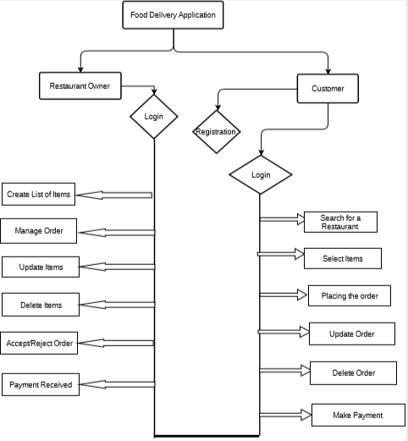

There are two types of users who would access the system viz. Customer and restaurant owner. Each one of them would have some exclusive privileges as follows

1. Restaurant owner
2. Customer

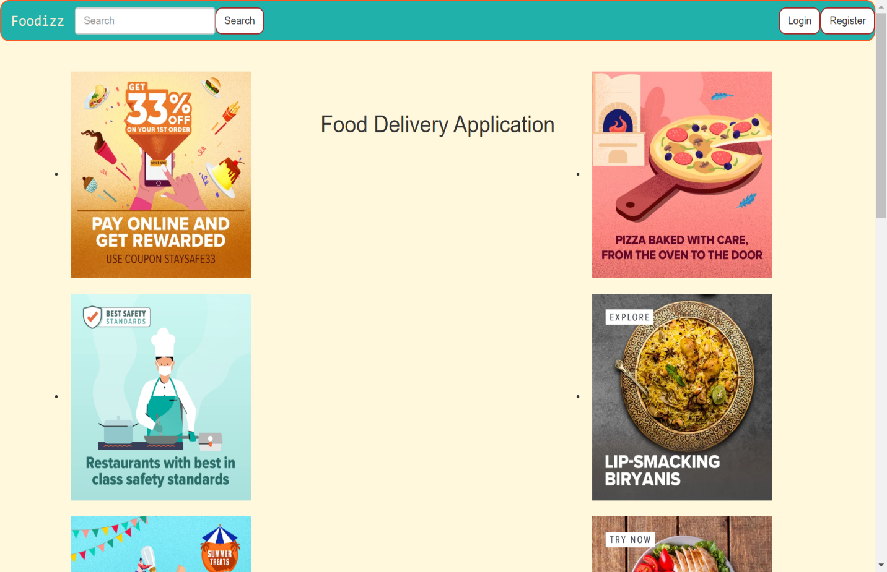

**Admin (Restaurant owner):**

The restaurant owner must have the following list of functionalities:

The restaurant owner will have the access to manage the menu to create the new items or update the food items or delete the items. The owner also has ability to accept or reject the order of the customer.

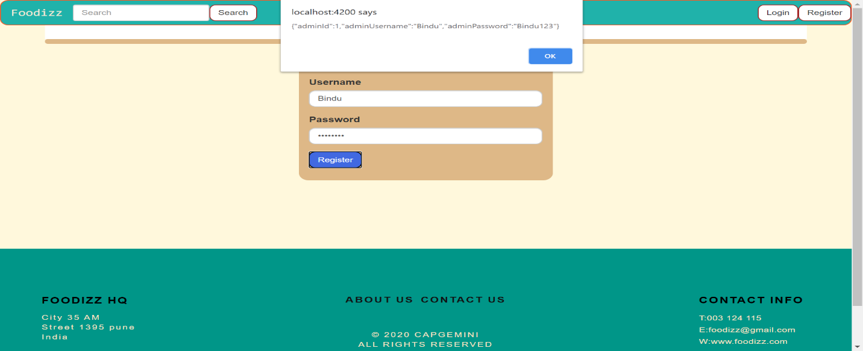

The Restaurant owner needs to be login by entering the valid username and password to give the restaurant menu. If the restaurant owner doesn’t login with his/her valid credentials he cannot add the items to his restaurant.

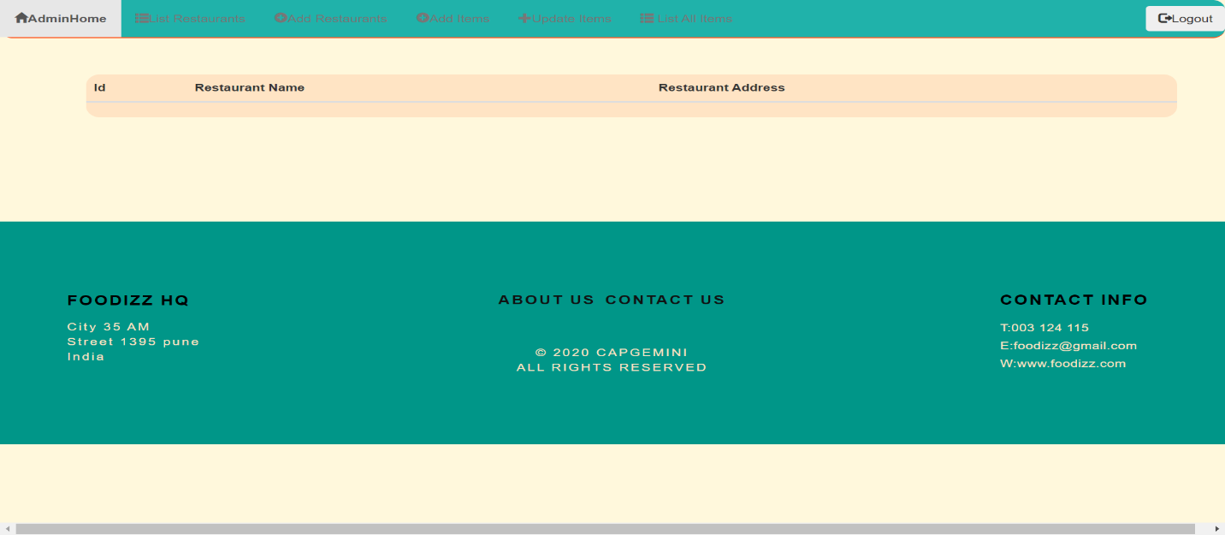

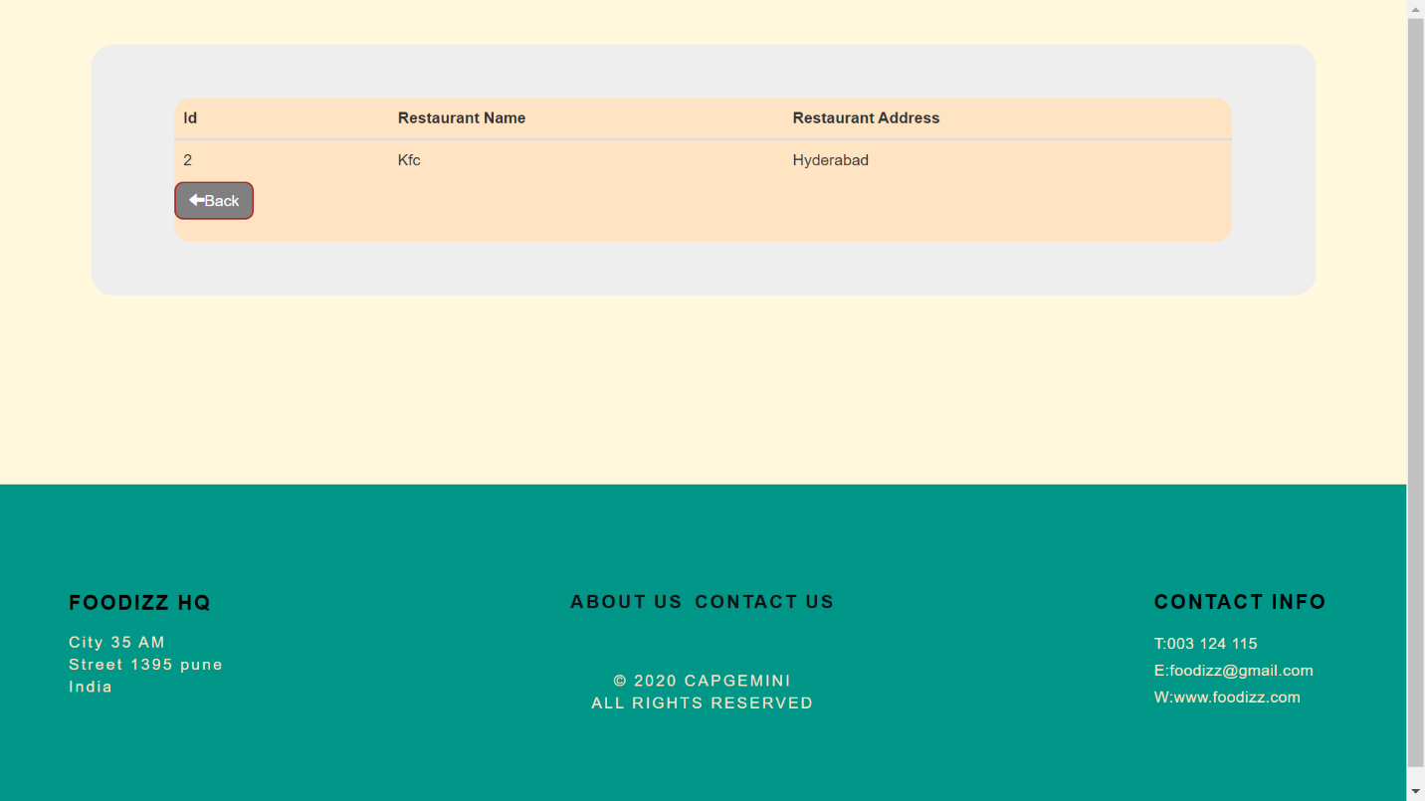**Using AdminId we have to add the Restaurants**

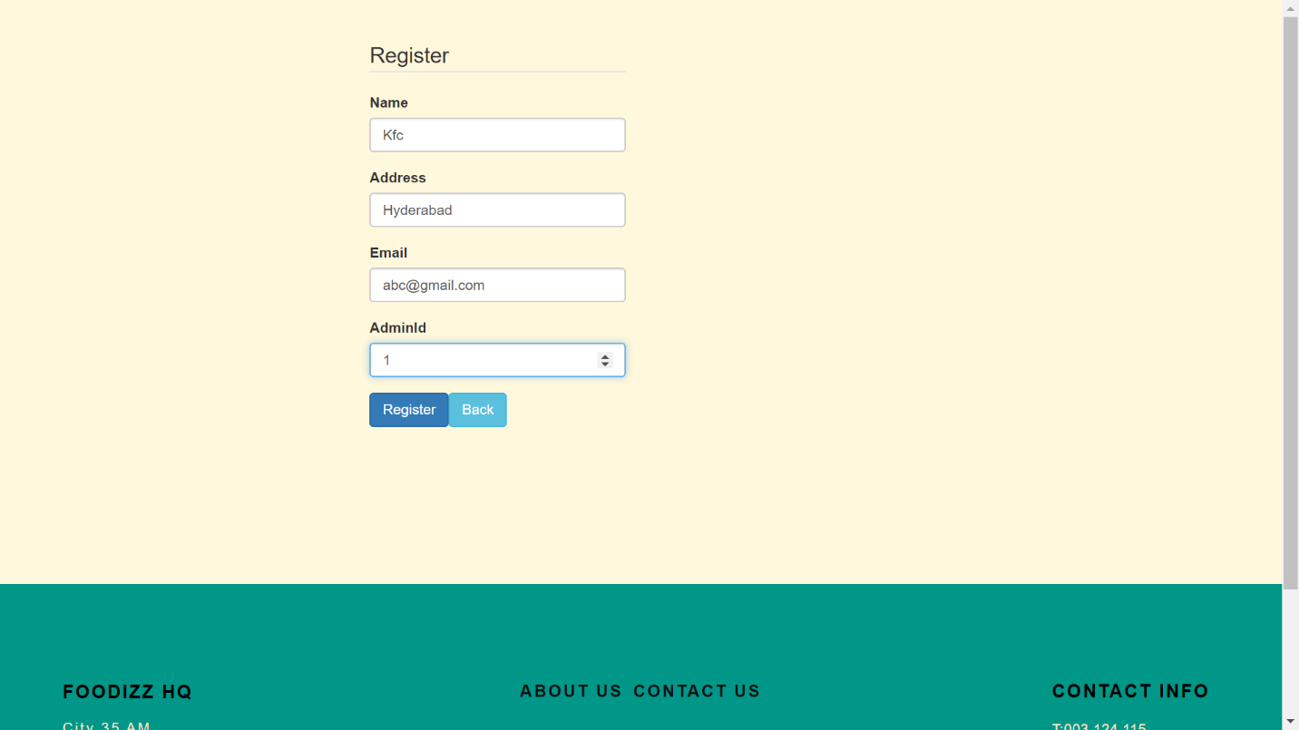

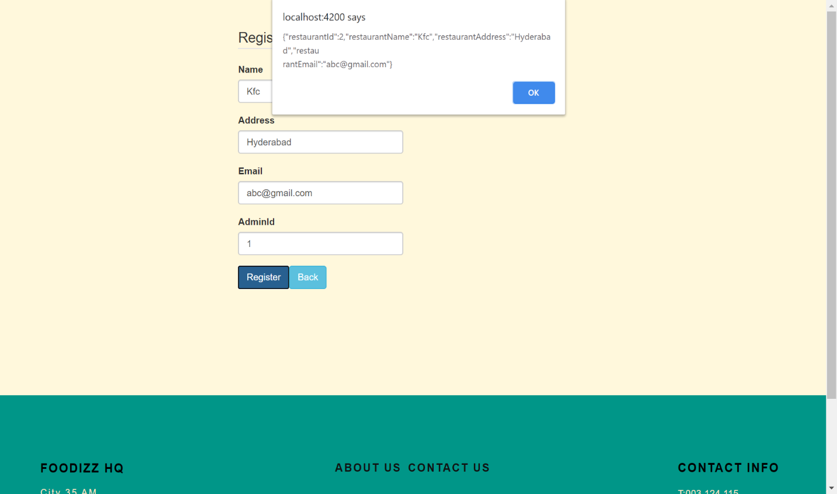

**List of Restaurants:**



**Create list of items**:

The owner can add his list of items to menu. So, customers can place an order. Using RestaurantId we have to add Food Items. Admin as the access to above

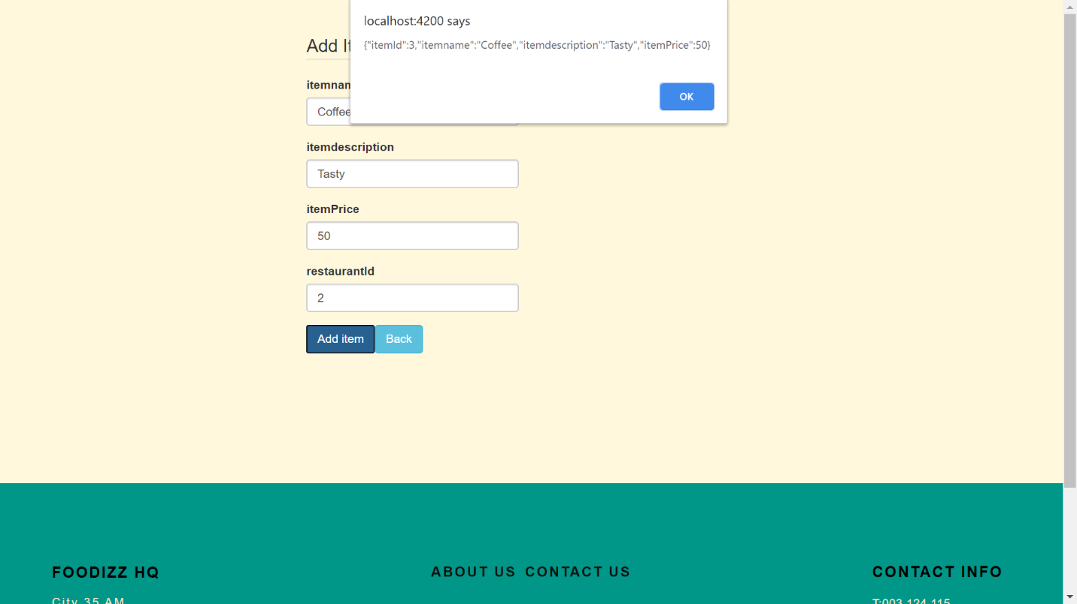

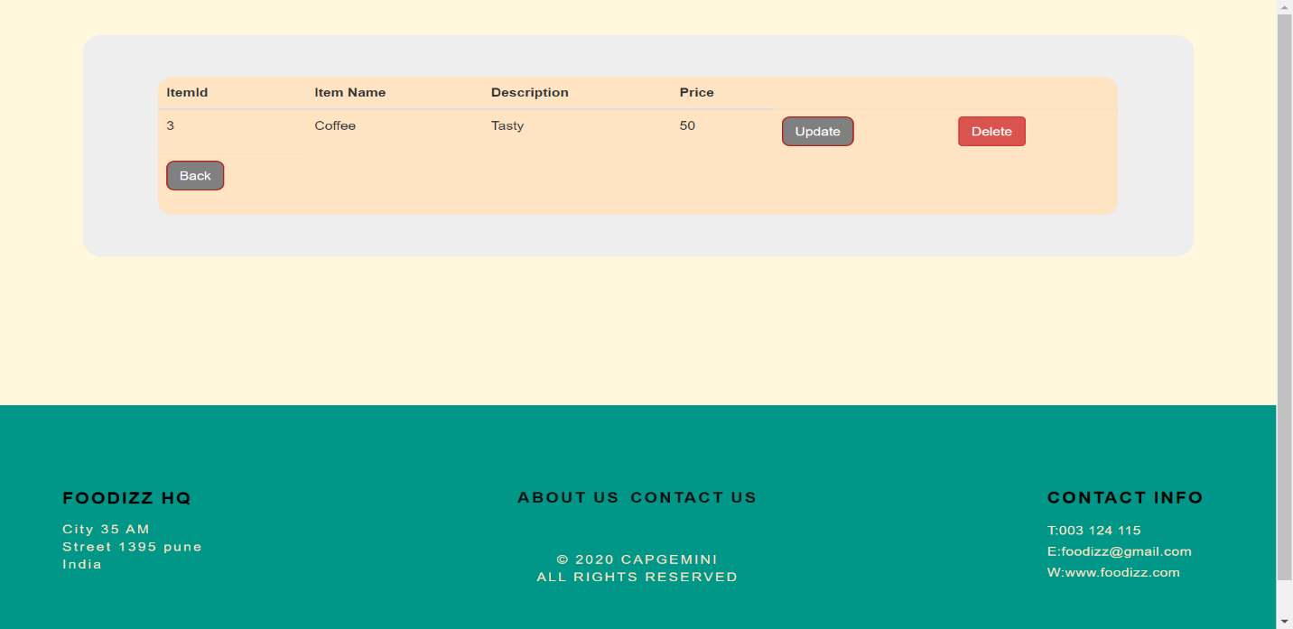

**Update items**:

The owner can update his list of food items in his menu.

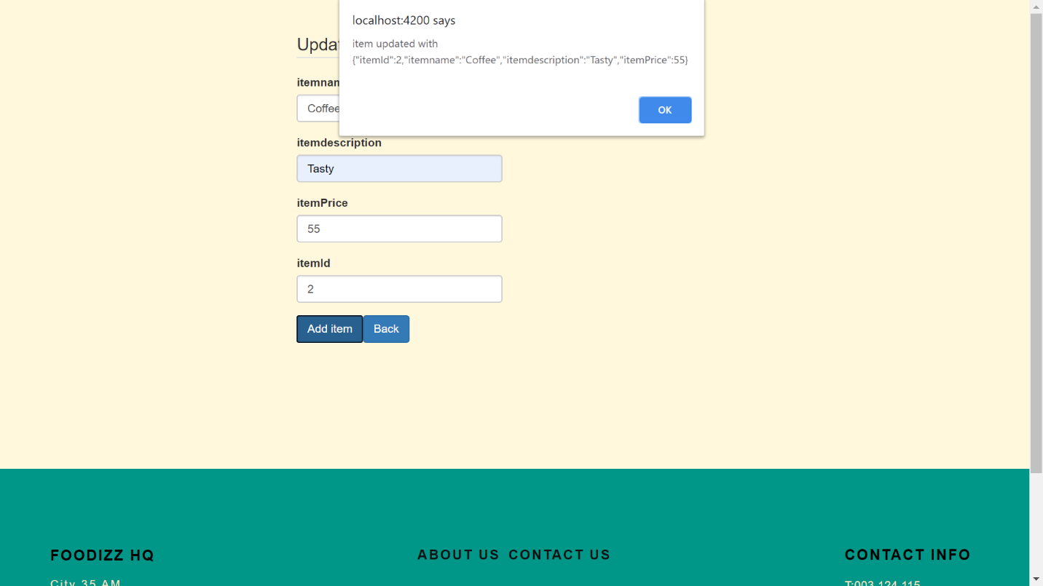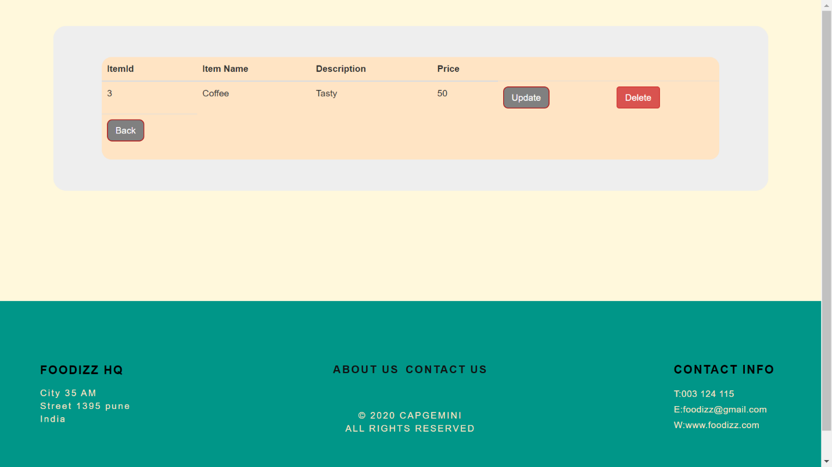

**Delete items**:

The owner can delete his list of food items from his menu

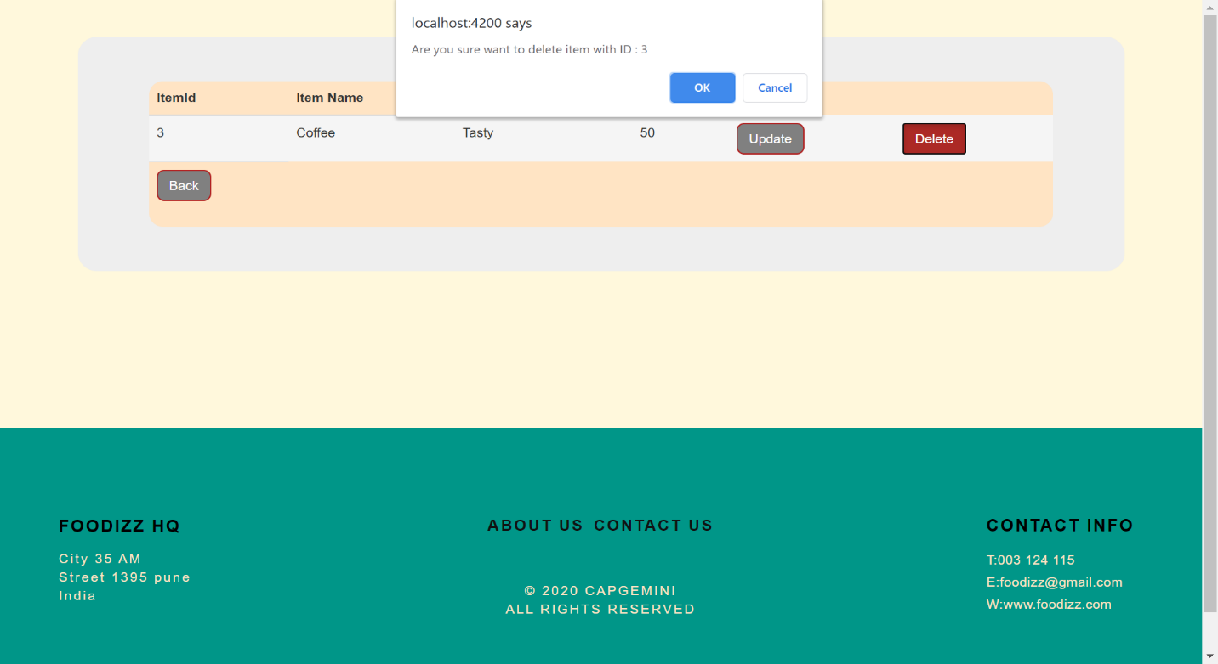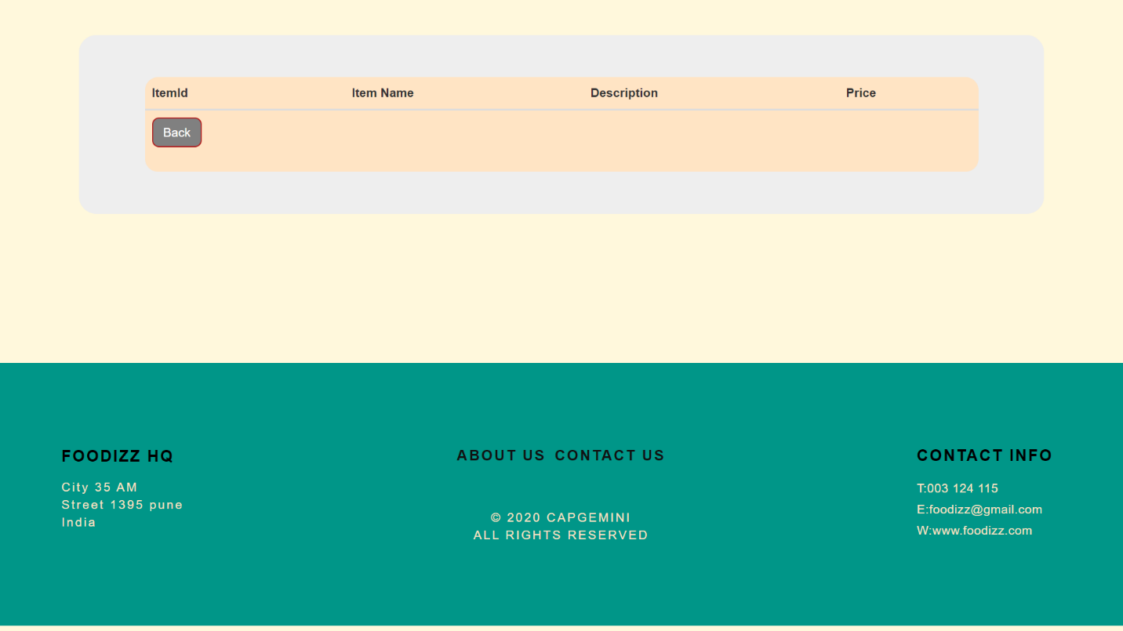

**Customer:**

The customer of the restaurant must have following functionality:

When the customer visits the Food delivery webpage, he/she needs to sign in. Once they are signed in they are presented with an interactive menu. After making a selection, the item is added to their order, which the customer can review the details at any time and place the order.

**Signup**

If a customer wants to place an order then he/she must be registered with their valid credentials. If a customer is not registered then he/she cannot place the order.

**Login**

The customer should login with his/her valid username and password for placing the order.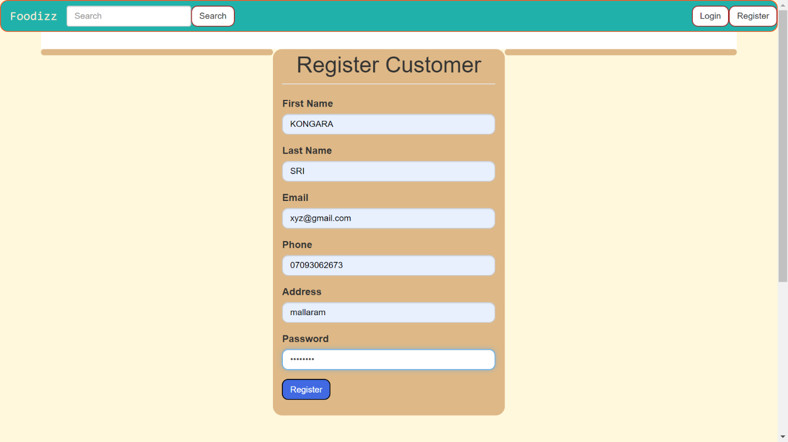

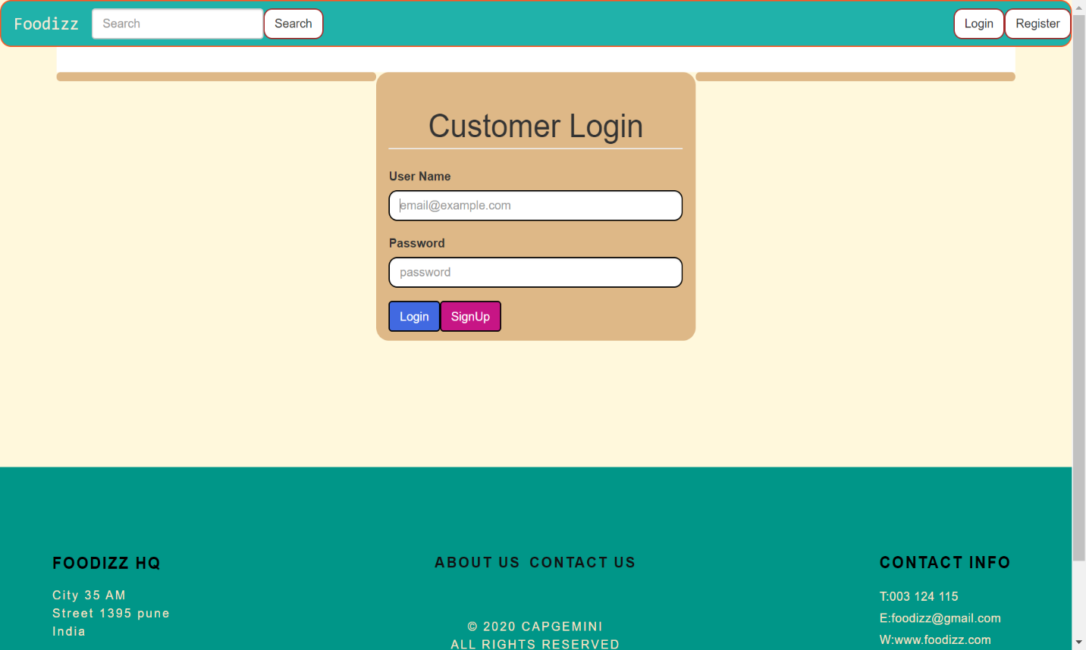

**Search for a Restaurant**:

The customer should search for a restaurant in order to place an order.

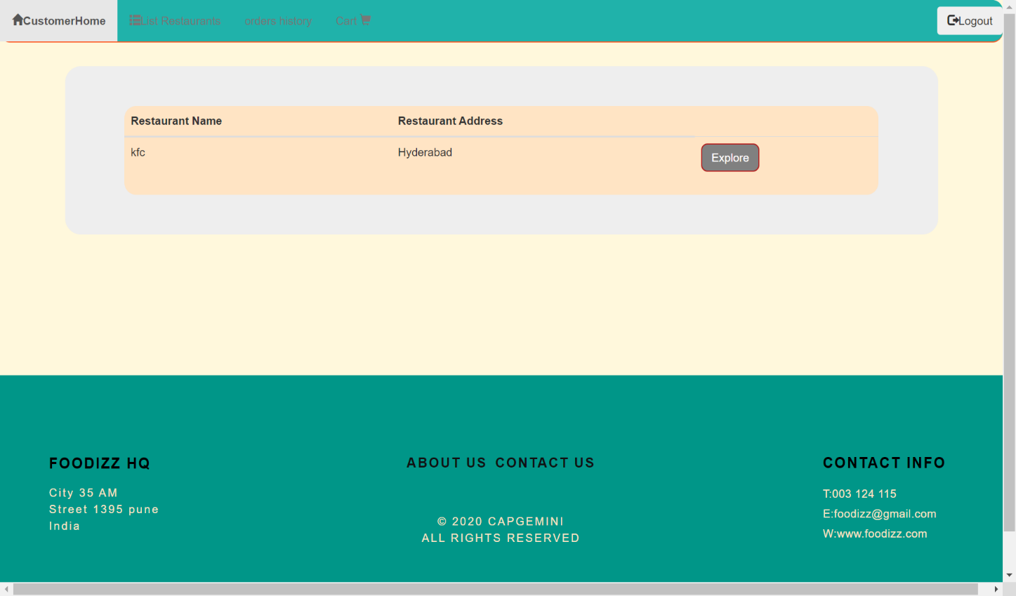

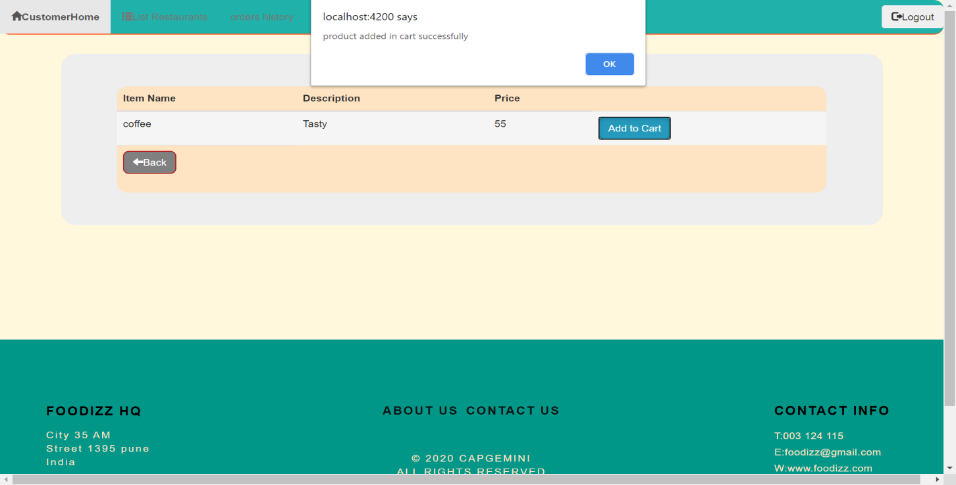

**Select items**:

The customer can select the items for ordering

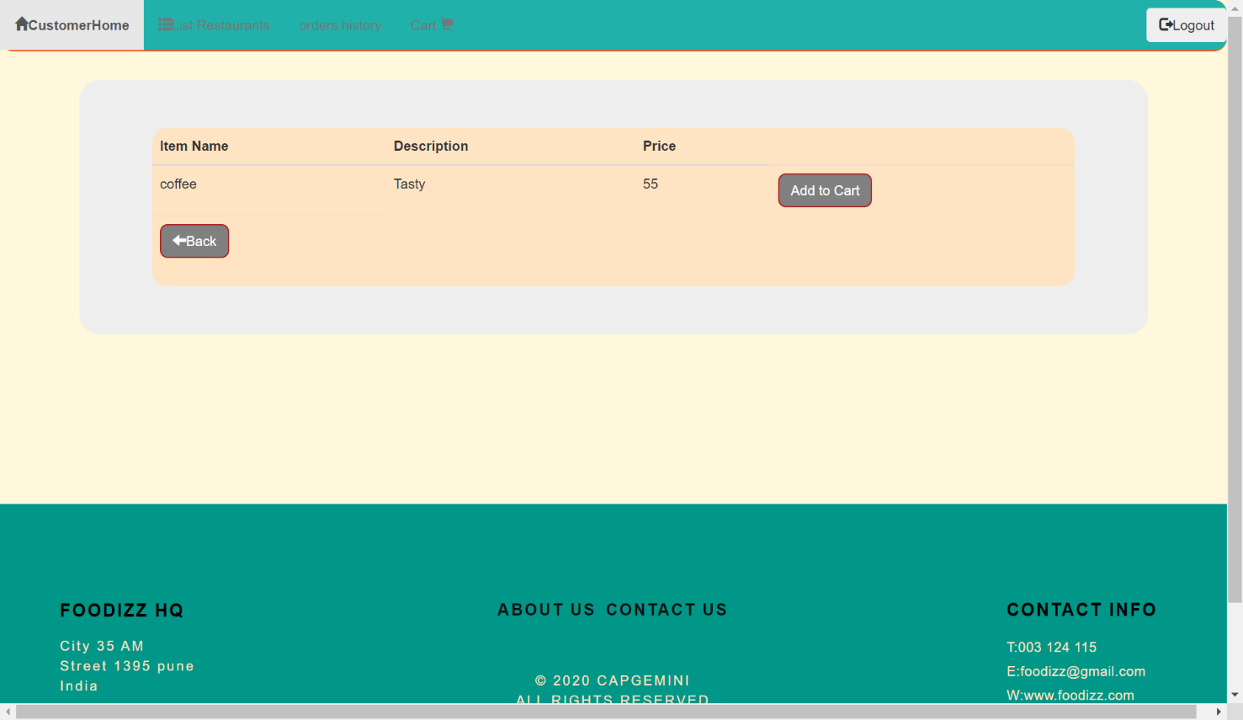

Add Items to Cart

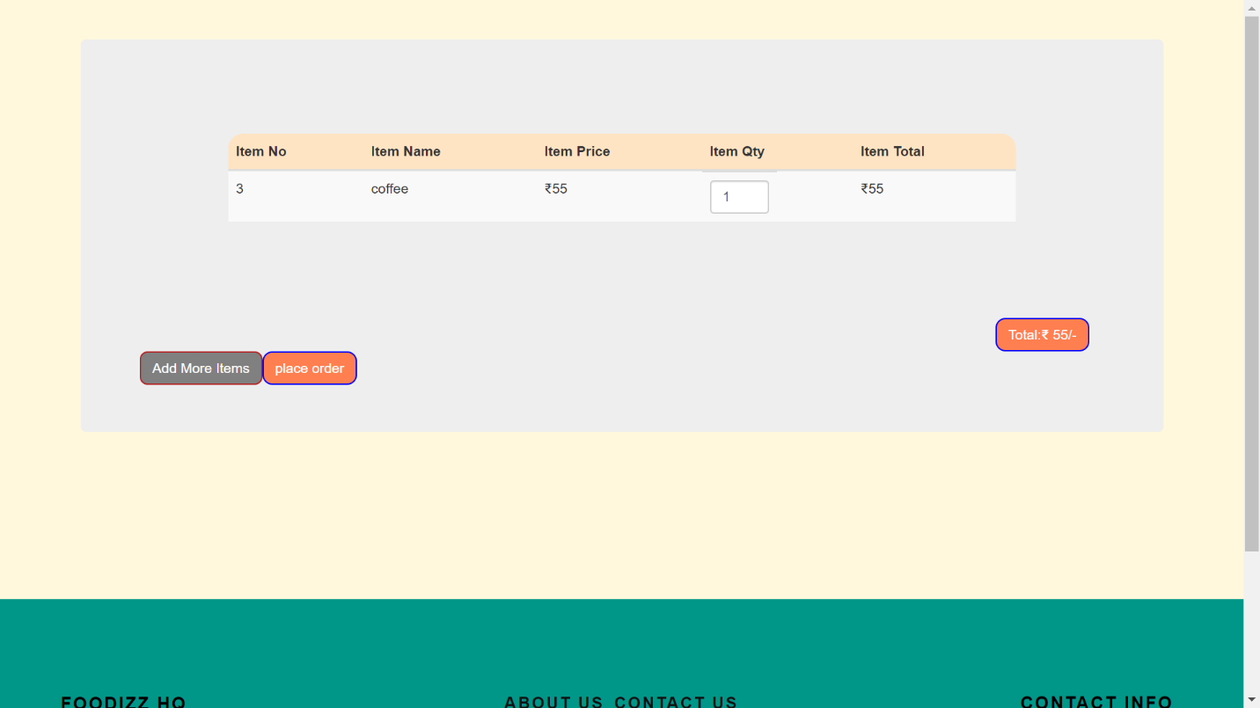**Place order**:

The customer places the order after selecting the items

**Make a payment**:

Once the order is placed, the customer can make a payment by debit/credit card

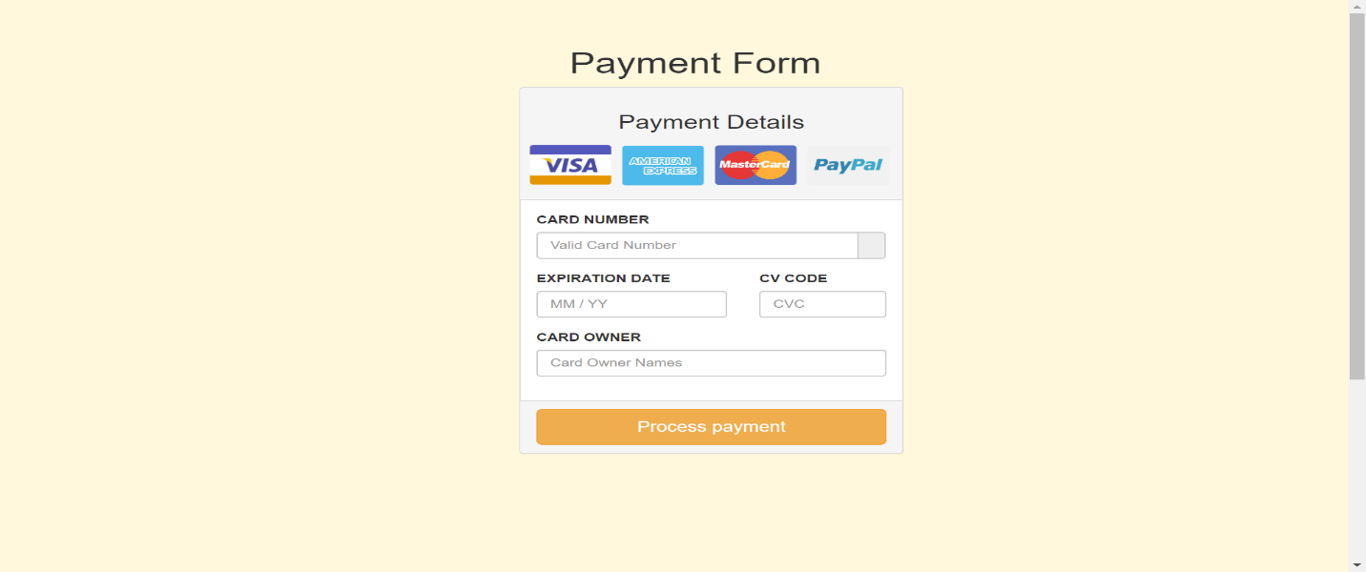

**About Us**

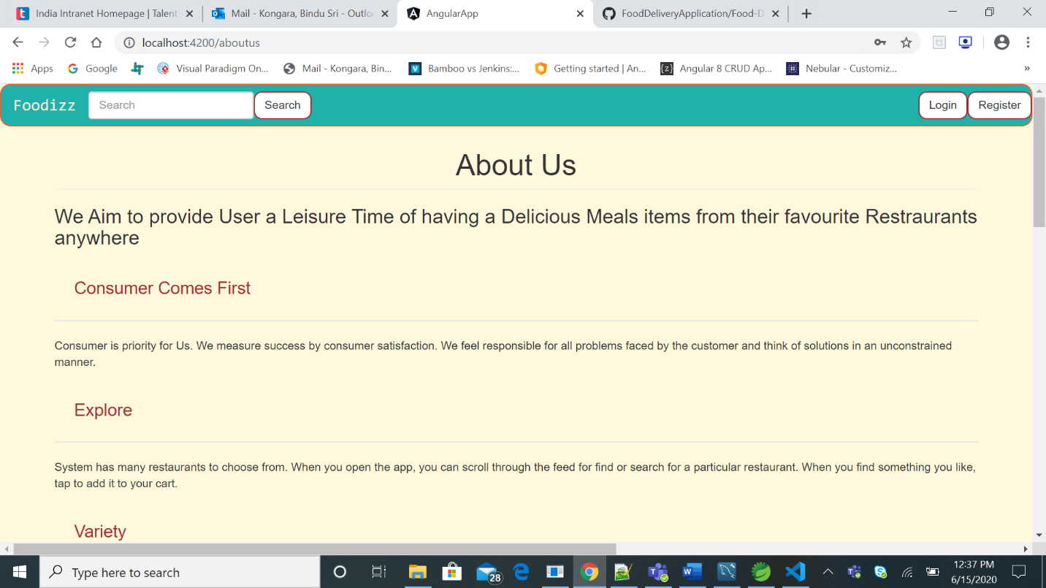

**Contact Us**

